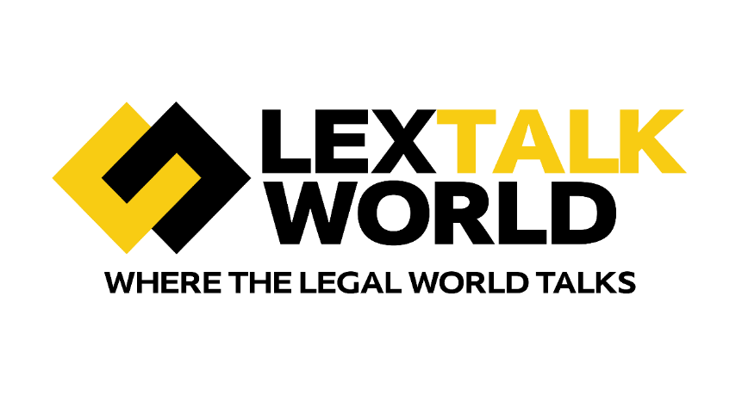

The [LexTalk World](https://www.lextalk.world/) Conference is a premier event that brings together professionals from the legal and technology sectors to explore the evolving intersection of these fields. The conference provides a dynamic platform for discussing innovations, emerging trends, and practical applications in legal technology. Attendees include legal professionals, technologists, and industry leaders who converge to examine how digital transformation is reshaping the legal landscape.

The event typically features diverse activities, including keynote speeches from thought leaders, panel discussions with industry experts, interactive workshops, and ample networking opportunities. Topics of focus often encompass legal tech advancements, regulatory challenges, and the future direction of legal services.

By fostering an environment of collaboration and knowledge sharing, the LexTalk World Conference aims to address current challenges and anticipate future developments in legal technology. Whether through exploring cutting-edge tools, debating best practices, or connecting with peers, participants gain valuable insights and practical strategies to navigate the complexities of the modern legal environment. This conference is an essential forum for anyone interested in the intersection of law and technology.

**LexTalk World upcoming conferences:**

**New York Conference**

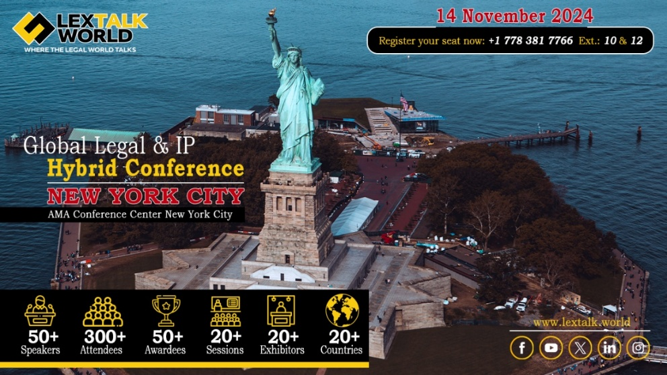

The 7th edition of the [LexTalk World](https://www.lextalk.world) Global Legal & IP Conference will take place in New York on November 14th, 2024. This conference will gather over 300 Legal, IP, and Technology leaders following successful events in Dubai, Singapore, and New Delhi. The event will feature two halls focusing on Legal & Tech and IP & Tech, covering topics like Governance, Risk, and Compliance (GRC), White-Collar Crime, Cybersecurity, Global IP Strategies, and Patent Law. This is a unique opportunity for professionals to discuss current trends and future insights in these critical areas.

**Visit Website**: <https://www.events.lextalk.world/newyork-2024>

**Register here:** <https://www.lextalk.world/event-details/global-legal-ip-hybrid-conference>

**Dubai Conference**

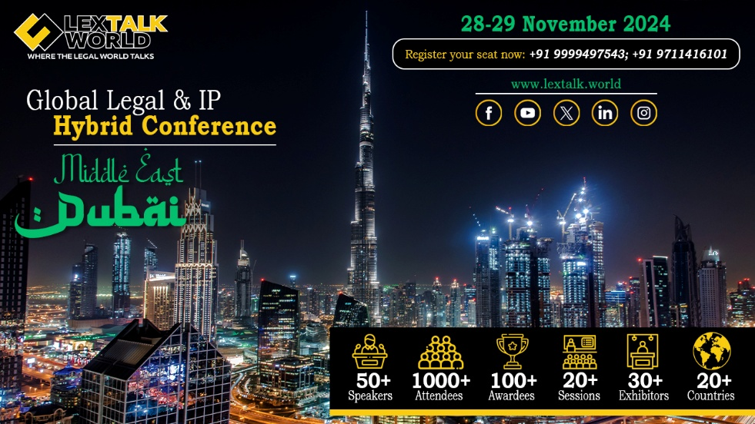

Join us for the 8th edition of [LexTalk World](https://www.lextalk.world/), Middle East, set to take place on November 28th & 29th, 2024, in the vibrant city of Dubai. This prestigious event, organized by ClickAway Creators, continues its tradition of providing a world-class platform for legal professionals to network, exchange cutting-edge knowledge, and celebrate their unwavering dedication to justice. With over 1000 legal experts expected to attend, this conference offers a unique opportunity to connect with leading corporates, law firms, and legal technology providers, fostering collaboration and innovation in the ever-evolving legal landscape. As our chosen venue, Dubai symbolizes the global momentum driving the transformation of the legal world.

**Visit Website**: <https://www.events.lextalk.world/middleeast-2024>

**Register here:** <https://www.lextalk.world/event-details/global-legal-ip-hybrid-conference-2>